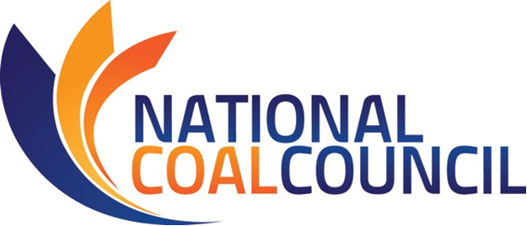

2017 ANNUAL SPRING MEETING
April 18-19, 2017 – Alexandria, Virginia

Sheraton Suites Old Town Alexandria, 801 N. Saint Asaph St., Alexandria, VA 22314
www.sheratonalexandria.com – 703-836-4700

FINAL AGENDA

Tuesday, April 18th, 2017
NCC Committee Meetings – Salon 1
11:30 am -1:15 pm NCC Carbon Management Subcommittee (NCC Members Only)
1:30-2:30 pm NCC Communications Committee Meeting (NCC Members Only)

4:30 pm NCC Meeting Registration Desk Opens – Hotel Lobby
5:30-6:00 pm New & Prospective Members’ Reception – Potomac Room
(New & Prospective Members & NCC Executive Committee Only)
6:00-7:30 pm Welcoming Reception – Fin & Hoof Restaurant – Hotel Lobby

Wednesday, April 19th, 2017
NCC Full Council Meeting – Sheraton Suites Conference Center
8:30 am – 12:15 pm Welcome – Michael D. Durham, Chair, National Coal Council
Antitrust Advisory – Julia d’Hemecourt
NCC Legal Counsel, Hunton & Williams

KEYNOTE PRESENTATIONS

U.S. DEPARTMENT OF ENERGY KEYNOTE
The Honorable Rick Perry
Secretary of Energy, U.S. Department of Energy
Introduction: Michael D. Durham, NCC Chair

INDUSTRY KEYNOTE
Stephen Nelson, Chief Operating Officer, Longview Power LLC
“Longview Power –
State-of-the-Art Clean Coal Technology for Reliable, Low-Cost Electrical Power”
Introduction: Greg Workman, NCC Vice Chair

BREAK (9:45-10:15 am)
Wednesday, April 19th, 2017 (continued)
Industry Presentations: Leading Edge Coal Technology Developments

Moderator – Janet Gellici, CEO, National Coal Council

Anthony Leo, Vice President of Applications & Advanced Technology Development
FuelCell Energy
“Fuel Cell Carbon Capture Pilot Plant:
FuelCell Energy’s DOE-Sponsored Program & Pilot Demonstration”

David Denton, Senior Director Business Development Energy, RTI International
Advanced Technologies for CO₂ Capture & Utilization: Power & Industrial Applications

Jared Moore, Ph.D., Principal, Meridian Energy
Thermal Hydrogen: An Emissions Free Coal/Gas Economy

National Coal Council Business Reports
Finance Committee ~
Gregory A. Workman, NCC Vice Chair & Finance Committee Chair
Coal Policy Committee ~
Deck Slone, NCC Coal Policy Committee Chair
Communications Committee ~
Lisa Bradley, PhD, DABT, NCC Communications Chair
Governance Issues ~
Janet Gellici, CEO, NCC

12:15-1:15 pm Networking Lunch – Fin & Hoof Restaurant – Hotel Lobby
Pre-registration and payment are required to attend.

THANK YOU SPONSORS
SOAP CREEK ENERGY
Tri-State Generation & Transmission
Occidental Petroleum & Charah, Inc.
ADA-ES & DOMINION ENERGY & FERREIRA CONSTRUCTION
& HEADWATERS & SAVAGE SERVICES

NCC Spring 2017 Program Development Committee
David Denton, RTI International
Ellen Ewart, Coronado Coal
Janet Gellici, National Coal Council
Jerry Oliver, Global Tech
Connie Senior, ADA ES
Revision: April 16, 2017

